FIGURES

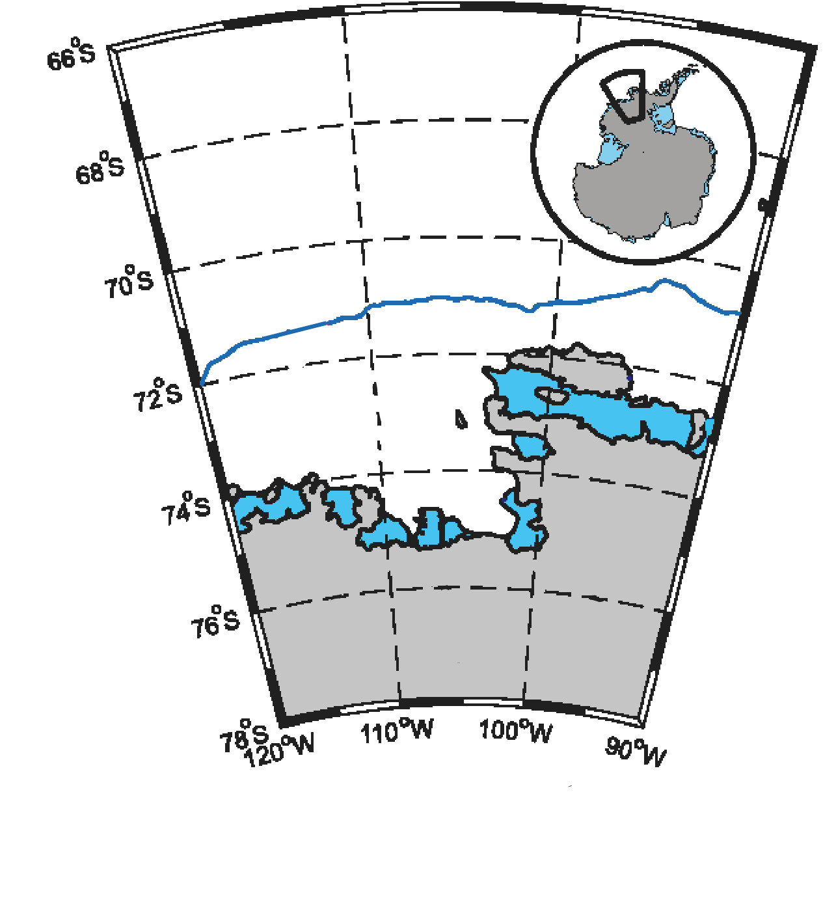

1000 m

Amundsen Sea embayment

Dotson

Thwaites

Pine

Island

**Figure 1a.** Map of the Amundsen Sea Embayment (modified from Walker et al. 2007).

*Southern Ocean*

**Figure 1b.** MODIS satellite image (*nsidc.org/data/iceshelves_images*) from Feb 2019 of southeastern Amundsen Sea with its two notable polynyas labeled in green and five rapidly melting ice shelves labeled in yellow.

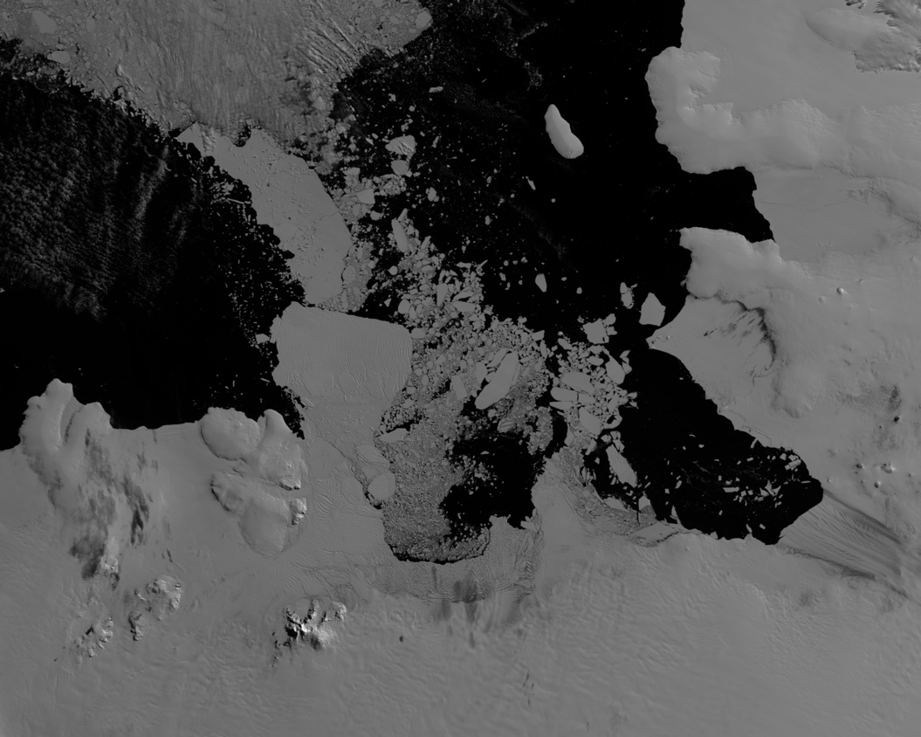

Cosgrove

Pine

Island

Thwaites

Dotson

Crosson

Amundsen Sea Polynya

Pine Island Polynya

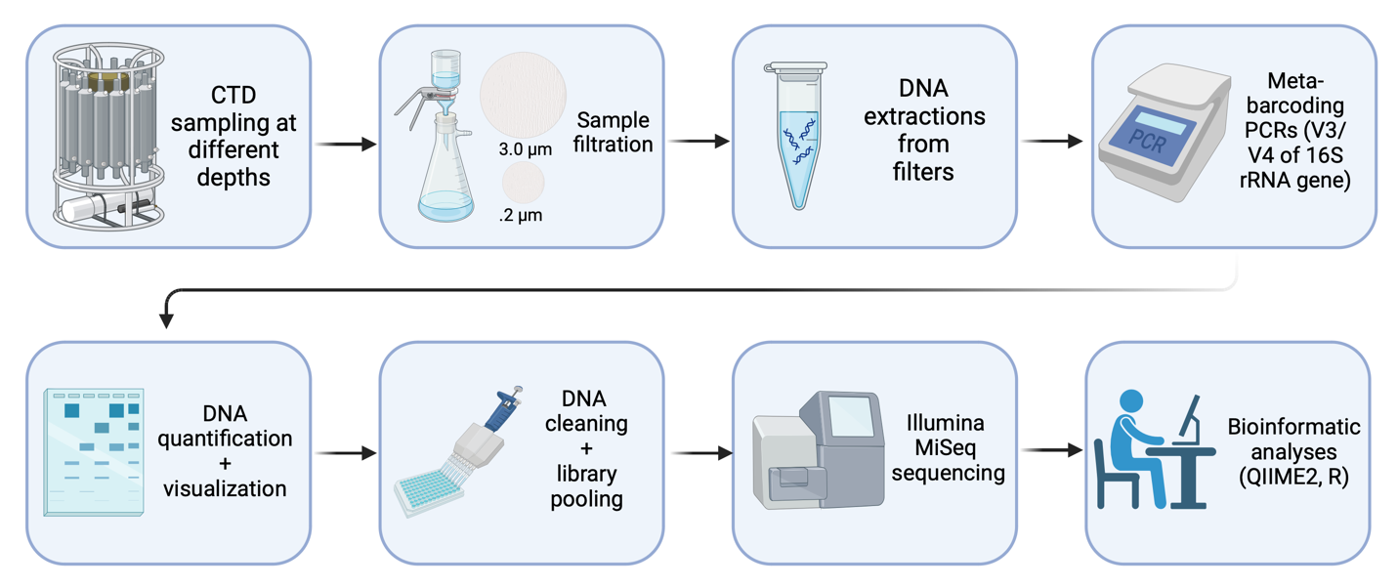

**Figure 1.** Pipeline of study.

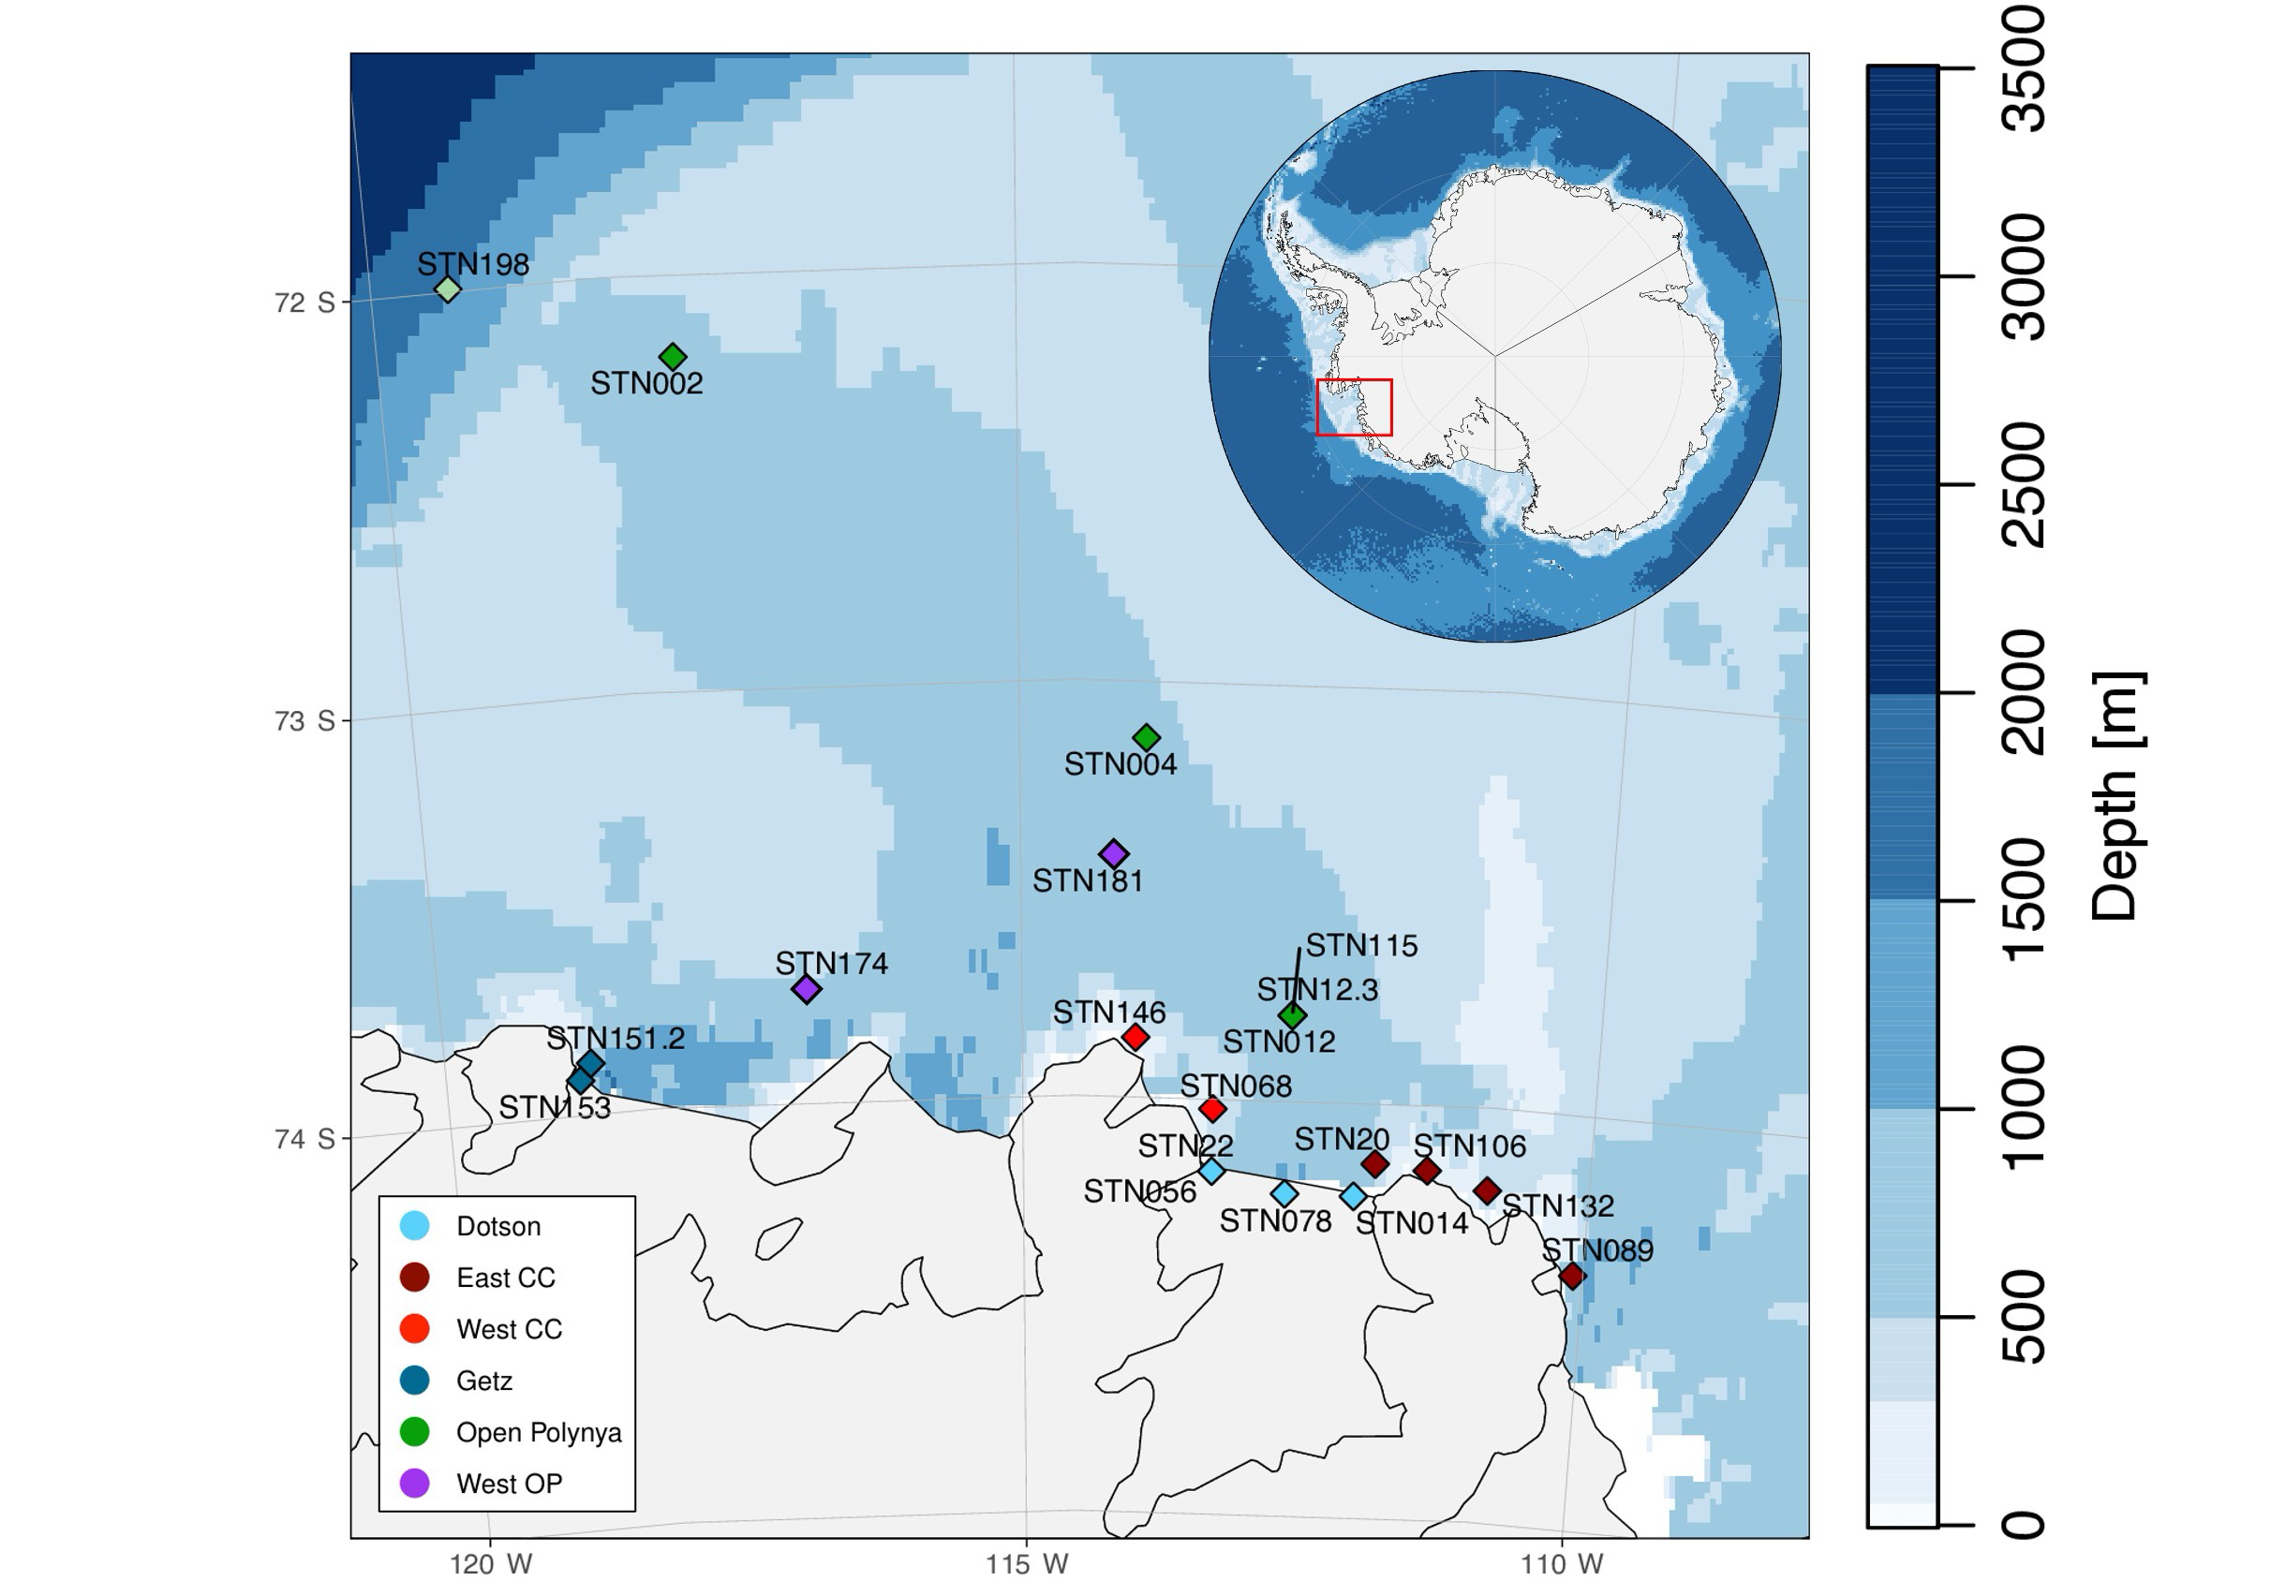

**Figure 2.** Station map with bathymetry. Colors are coordinated with location.

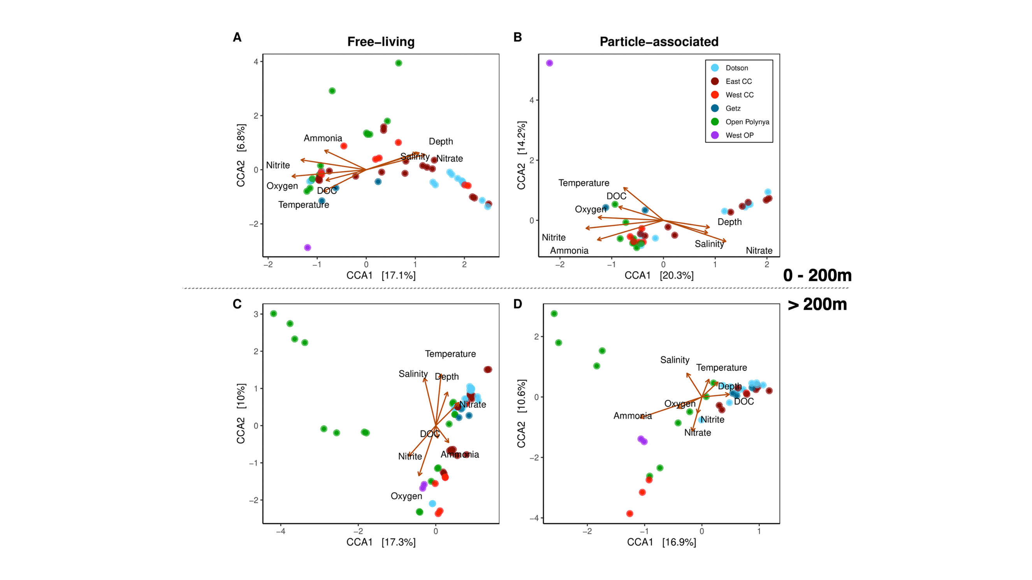

**Figure 3.** Canonical Correspondence Analysis (CCA) of free-living (**A, C**) and particle-associated (**B, D**) bacterial communities based on **location** within the ASP. First row CCAs are surface-200m and bottom row CCAs are 200m-bottom.

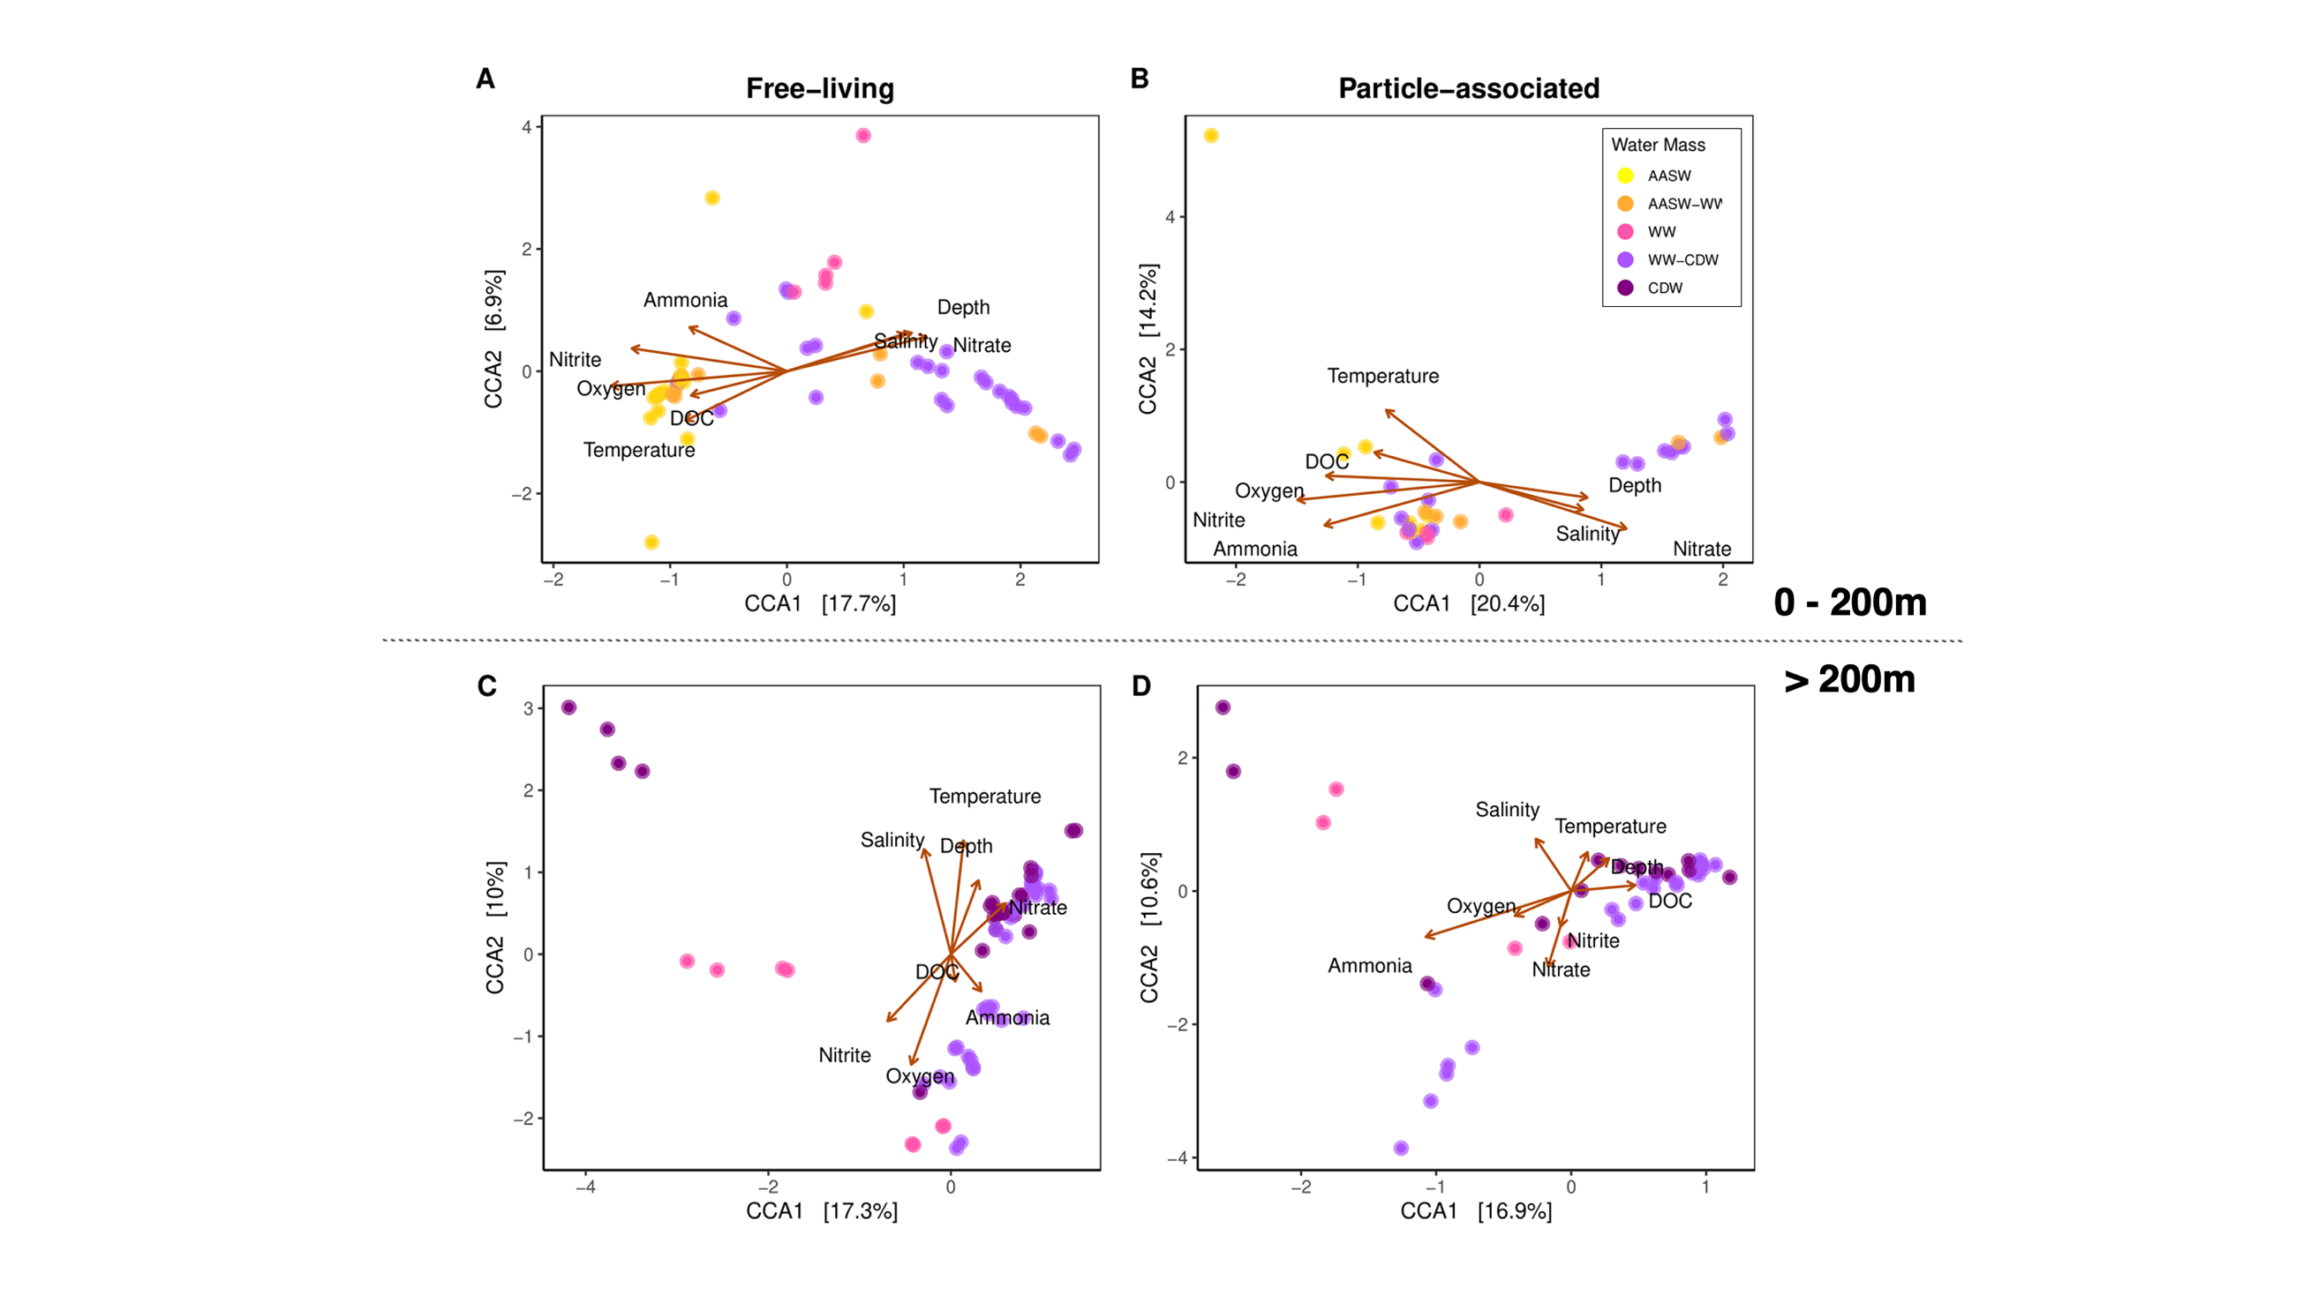

**Figure 4**. Canonical Correspondence Analysis (CCA) of free-living (**A, C**) and particle-associated (**B, D**) bacterial communities based on defined **water mass**. First row CCAs are surface-200m and bottom row CCAs are 200m-bottom.

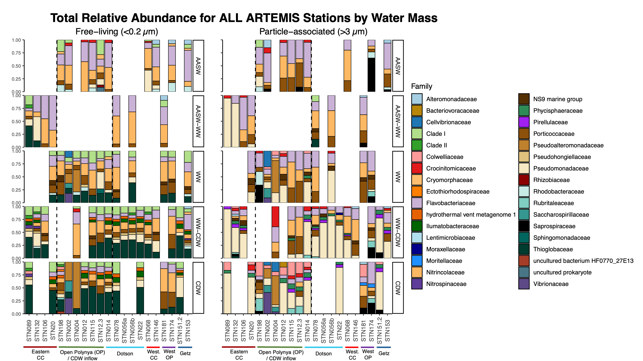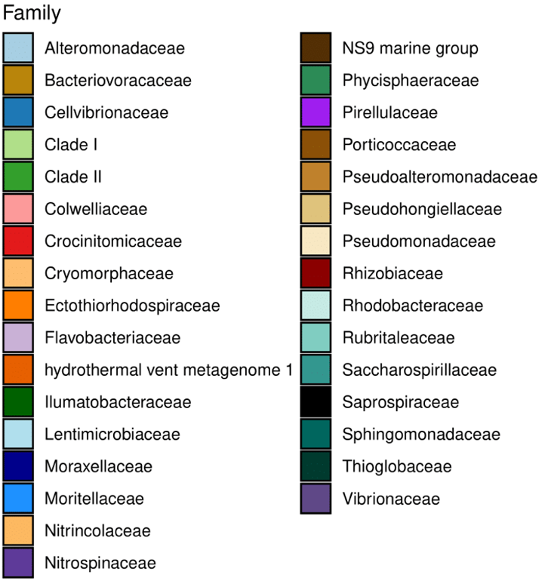

**Figure 5a.** Relative abundance for free-living (left) and particle-associated (right) communities at the family level. Each row represents a water mass, labeled on the right.

**Figure 5b.** Legend for the Family-level taxa that corresponds with Figure 5a.

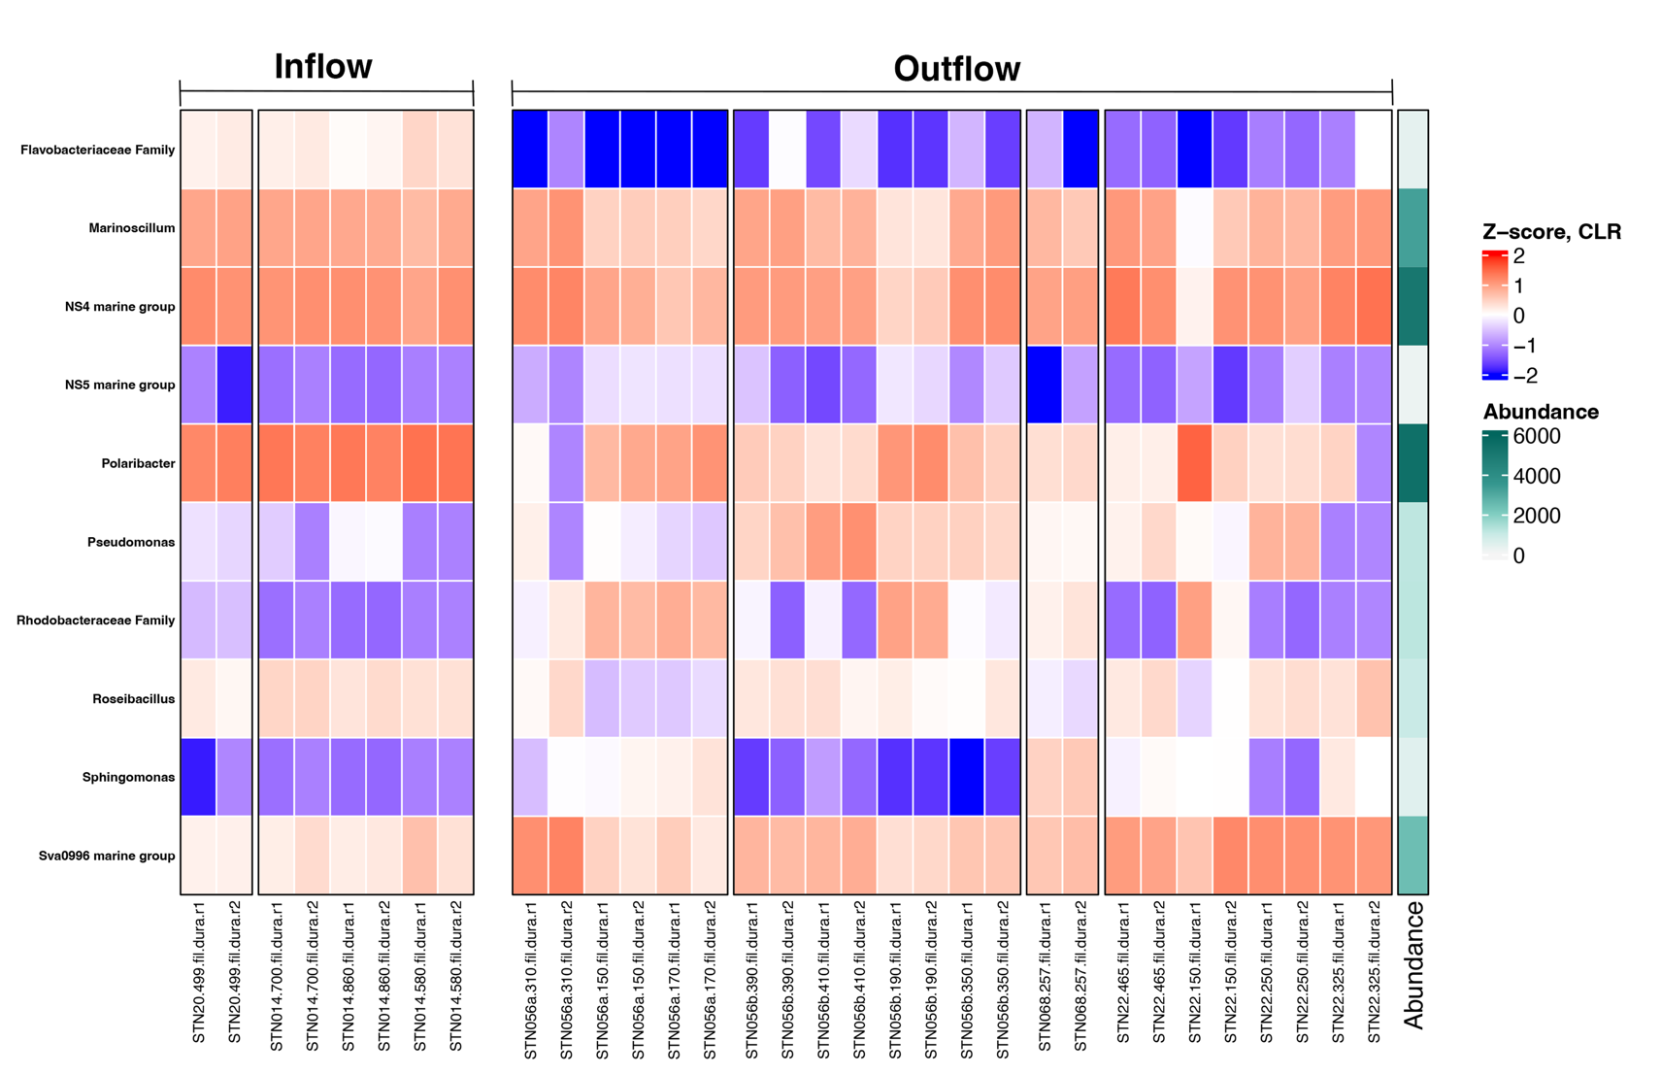

**Figure 6.** Significant **free-living** taxa from ANCOM-BC analysis for inflow vs. outflow samples. Z-score derived from log-transformed data. No significant change in particle-associated taxa from ANCOM-BC analysis.

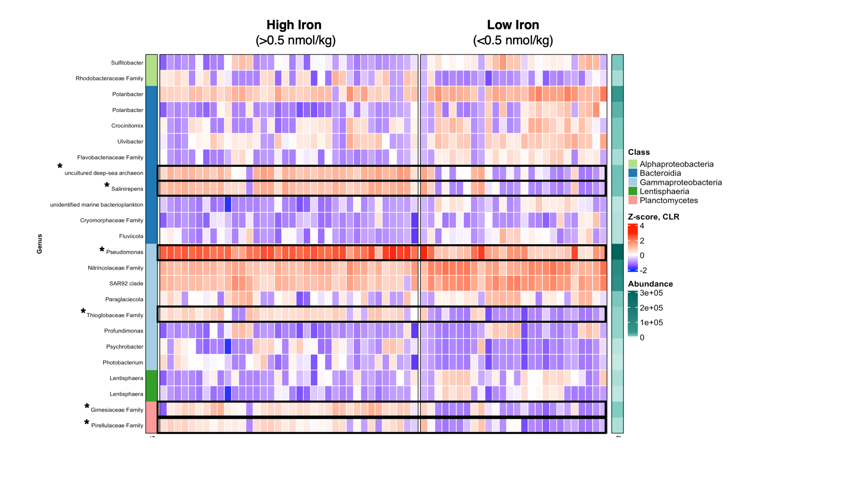

**Figure 8**. Significant **particle-associated** taxa from ANCOM-BC analysis for high (>0.5 nmol/kg) or low (<0.5 nmol/kg) dFe concentrations. Z-score derived from log-transformed data. See Supplementary Information for significant free-living taxa (**Figure S4**).

TABLES

**Table 1.** Water mass characterization with temperature and salinity ranges.

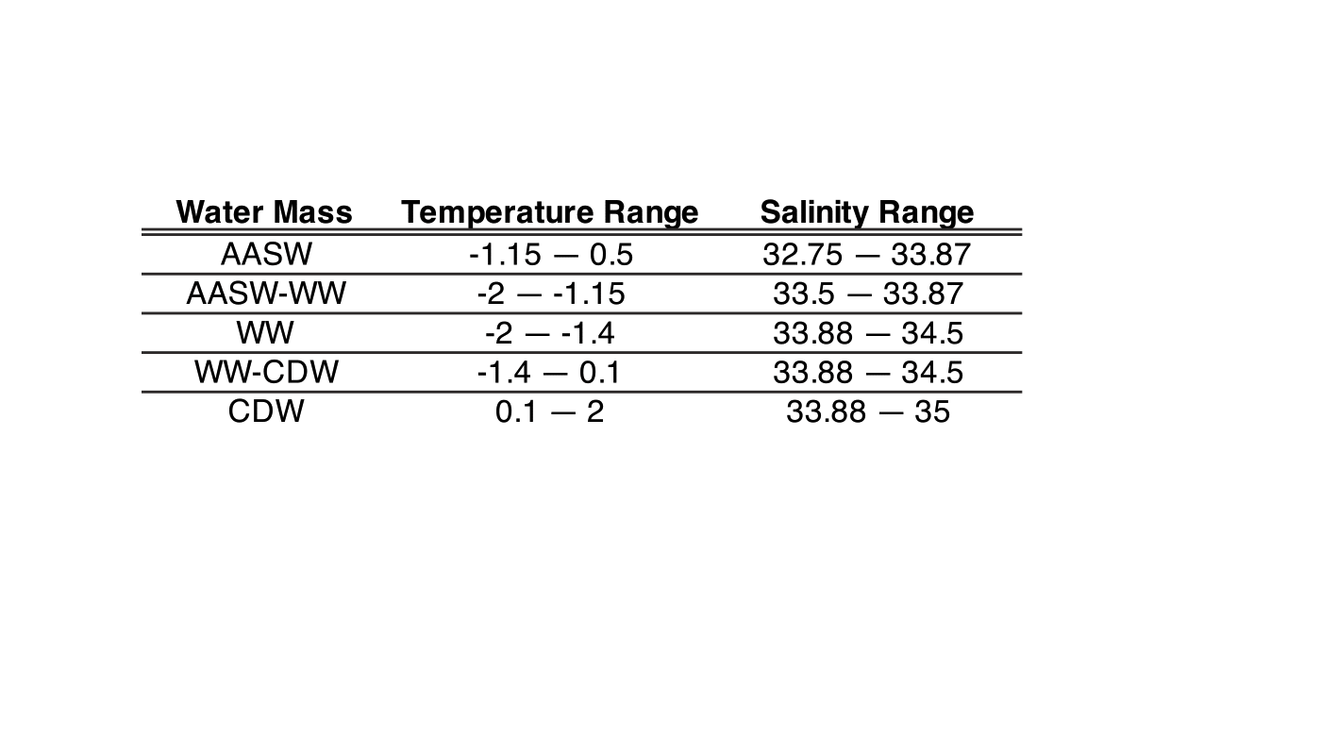

**Table 2**. Inflow and outflow stations and depth.

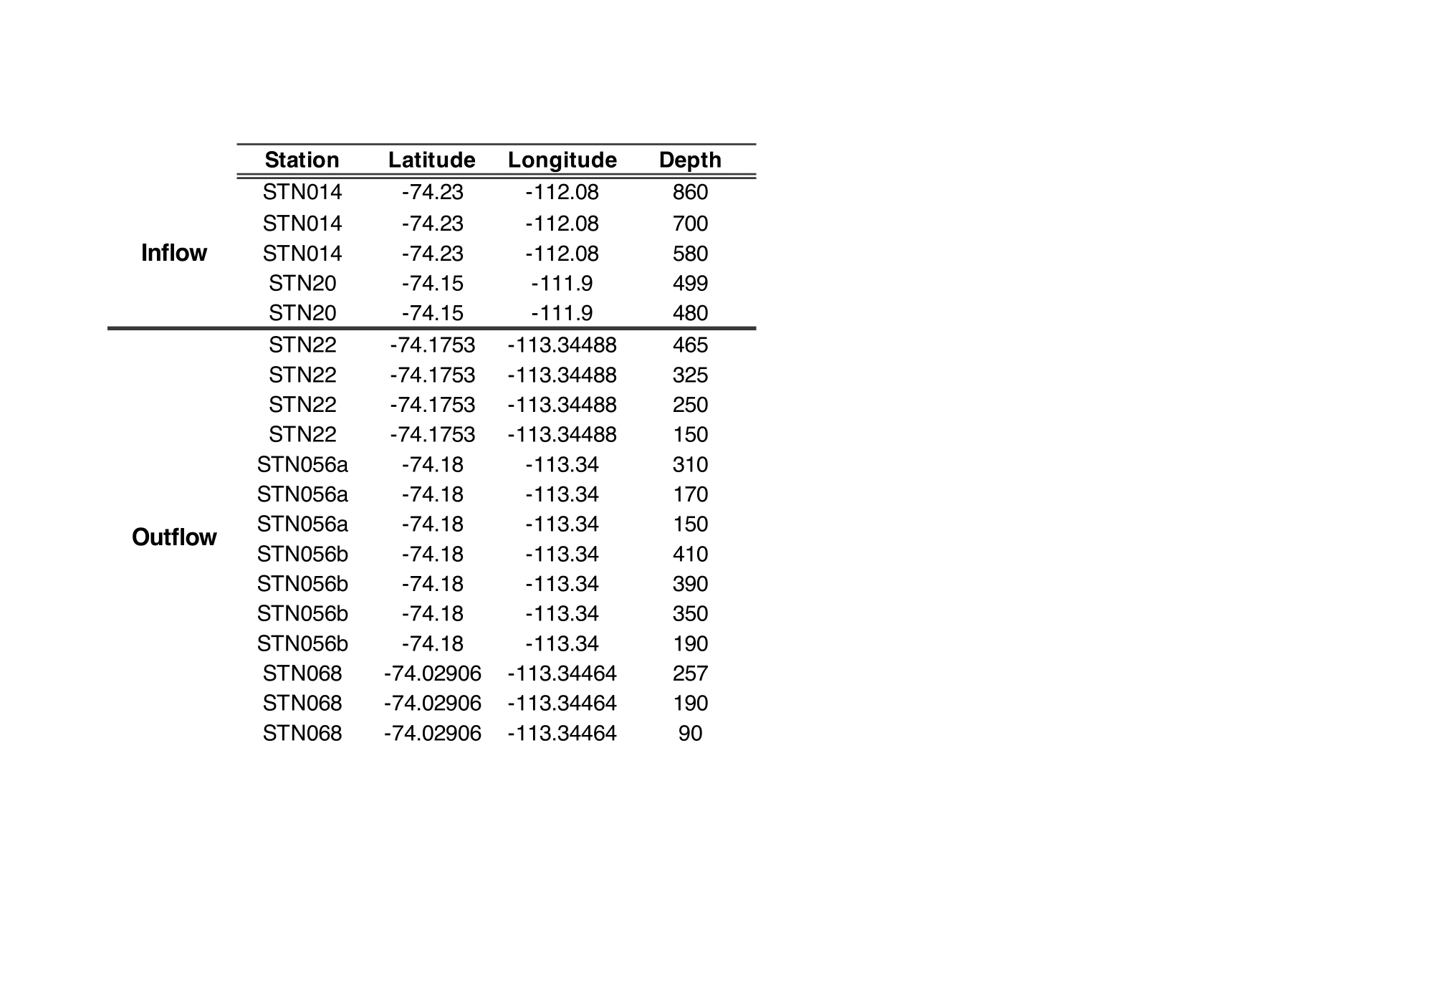

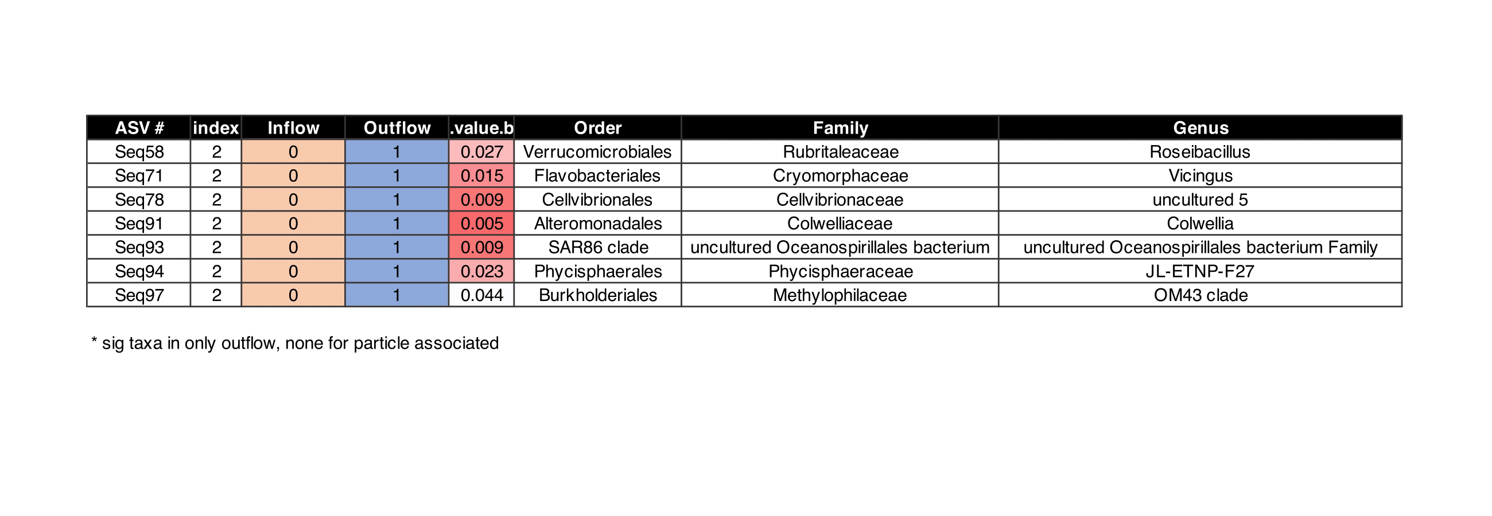

**Table 3.** Indicator species analysis of significant taxa in **free-living** outflow community. No significant indicator taxa appeared for particle-associated community.

SUPPLEMENTARY FIGURES



**Figure S1.** Temperature-Salinity plot for all ARTEMIS CTD casts, with oxygen as color and black points as samples with DNA collected.

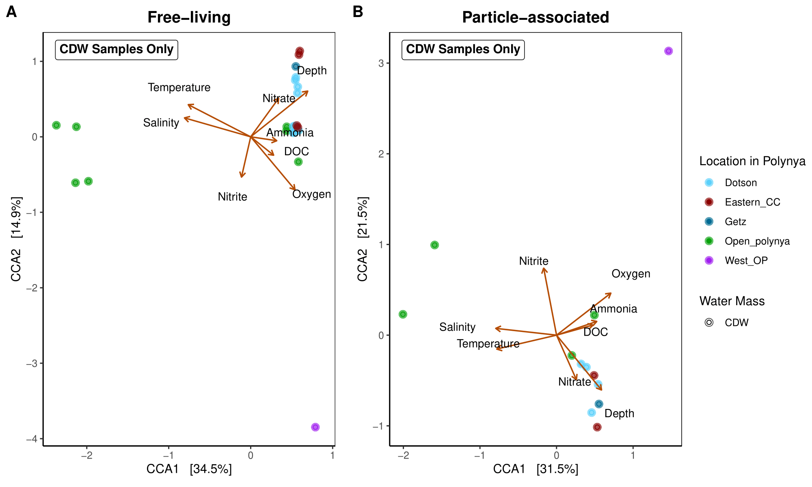

**Figure S2.** Canonical Correspondence Analysis (CCA) of free-living (**A**) and particle-associated (**B**) of samples that are characterized in CDW water mass, which are bottom water samples.

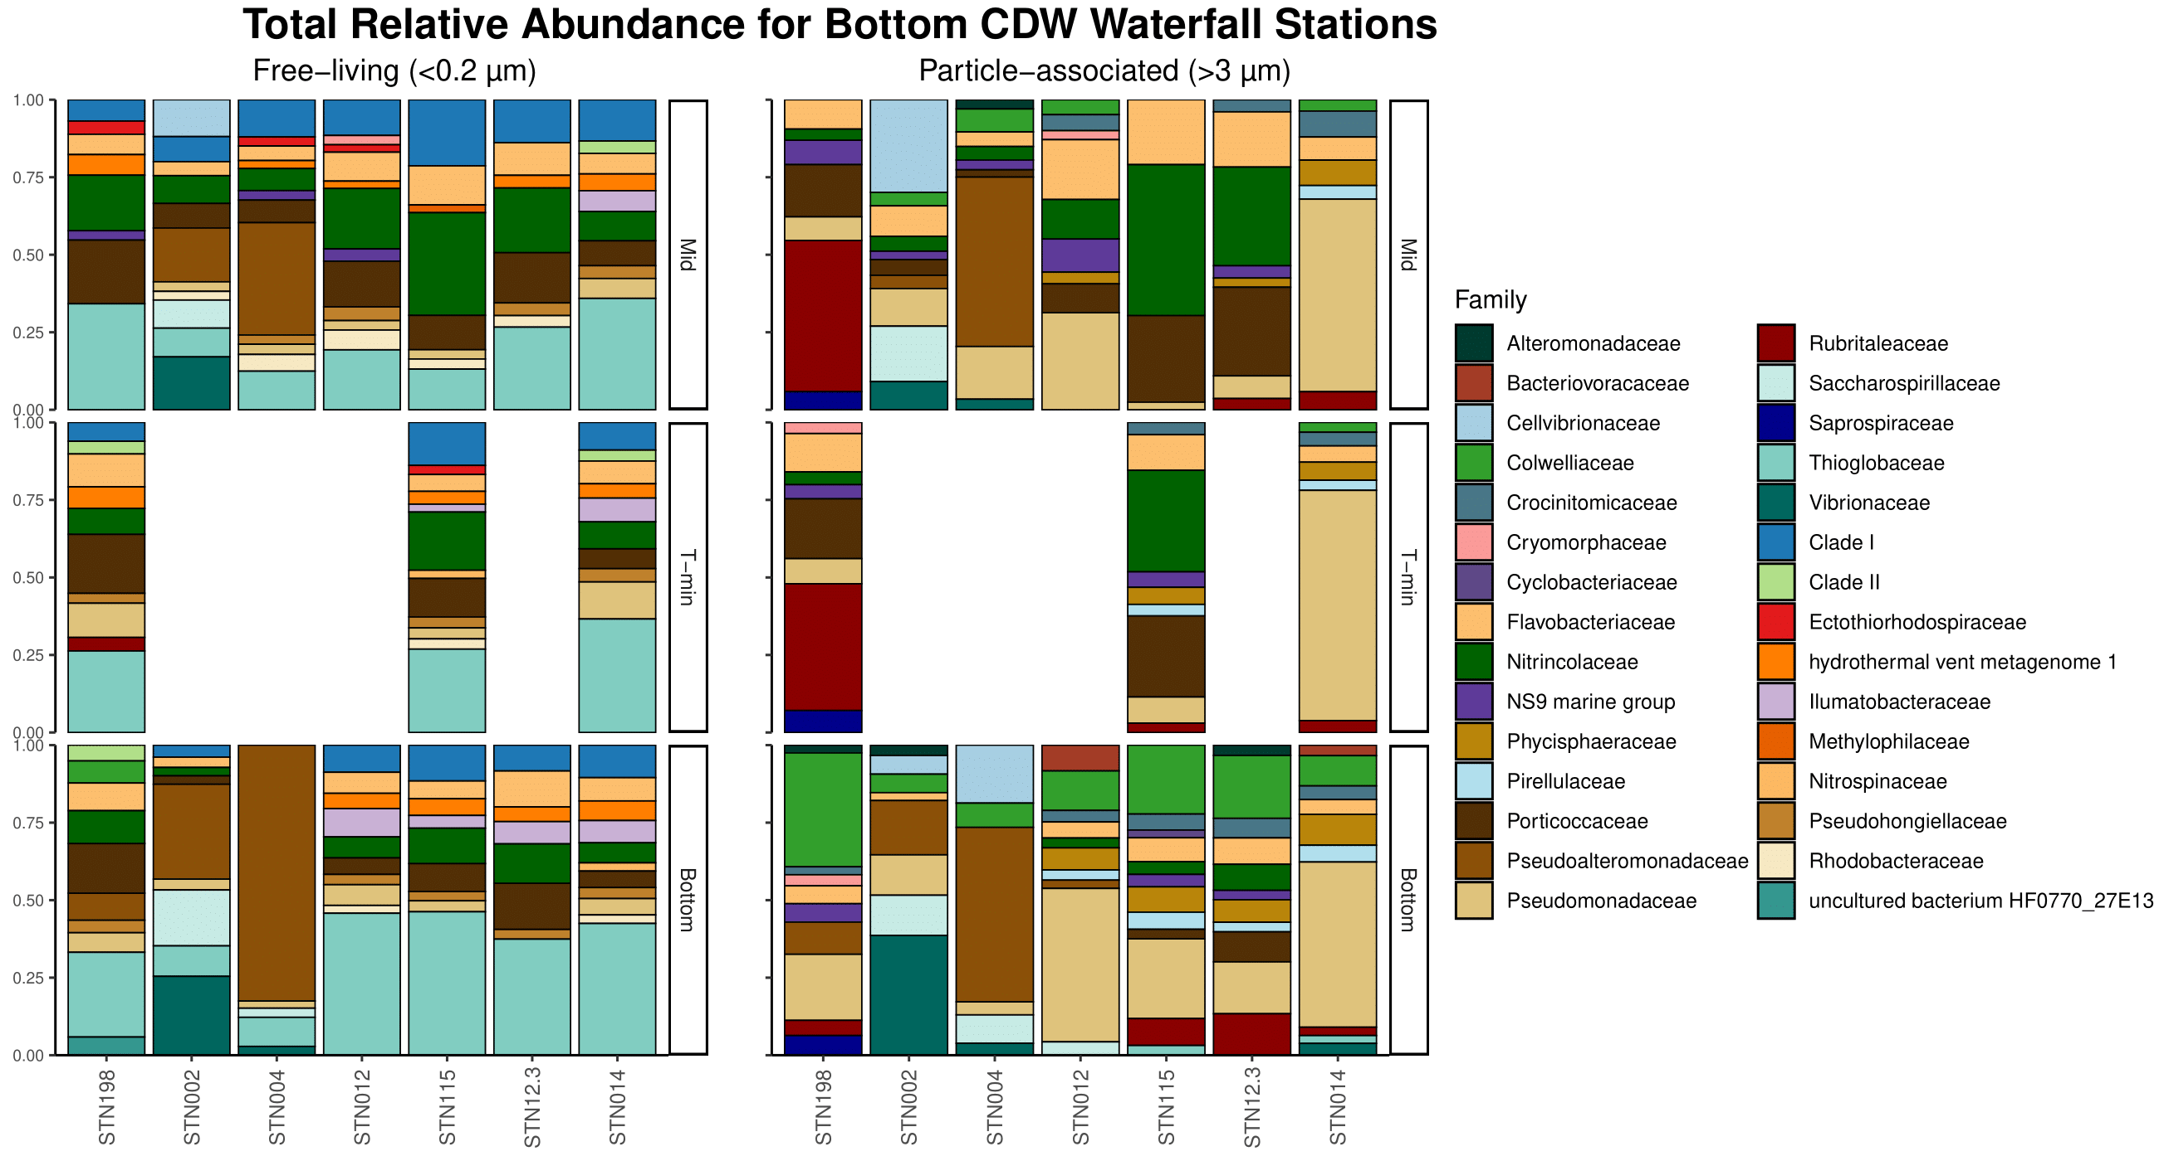

**Figure S3.** Relative abundance of stations coming from off the continental shelf at the family level. Free-living on left and particle-associated on the right.

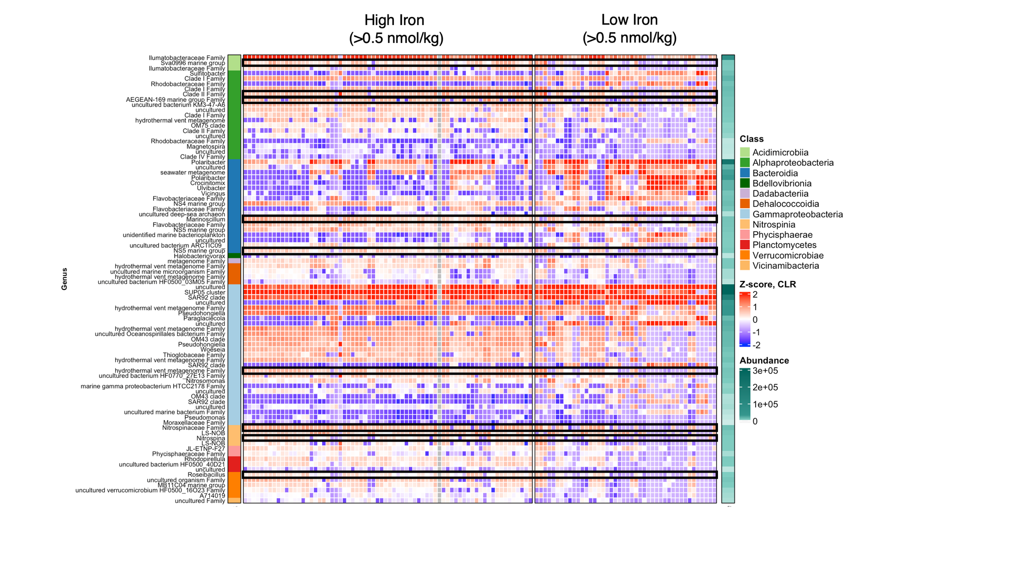

**Figure S4**. Significant **free-living** taxa from ANCOM-BC analysis for high (>0.5 nmol/kg) or low (<0.5 nmol/kg) dFe concentrations. Z-score derived from log-transformed data.

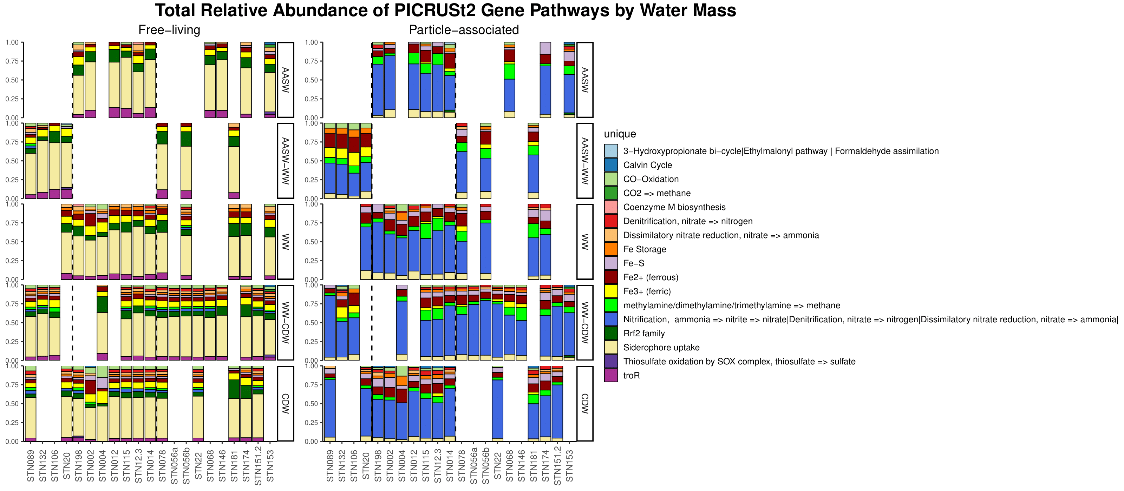

**Figure S5a**. Relative abundance of PICRUSt2 KO numbers by water mass and station. Free-living on left and particle-associated on the right.



**Figure S5b.** Legend that corresponds to **Figure S5a.**

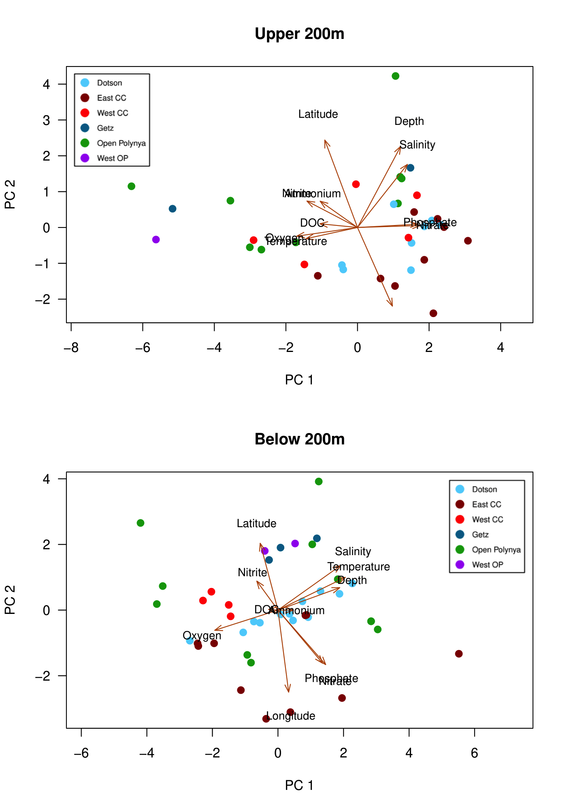

**Figure S6.** PCA of sample metadata by location in the ASP. Top PCA is surface-200m and bottom PCA is 200-bottom.

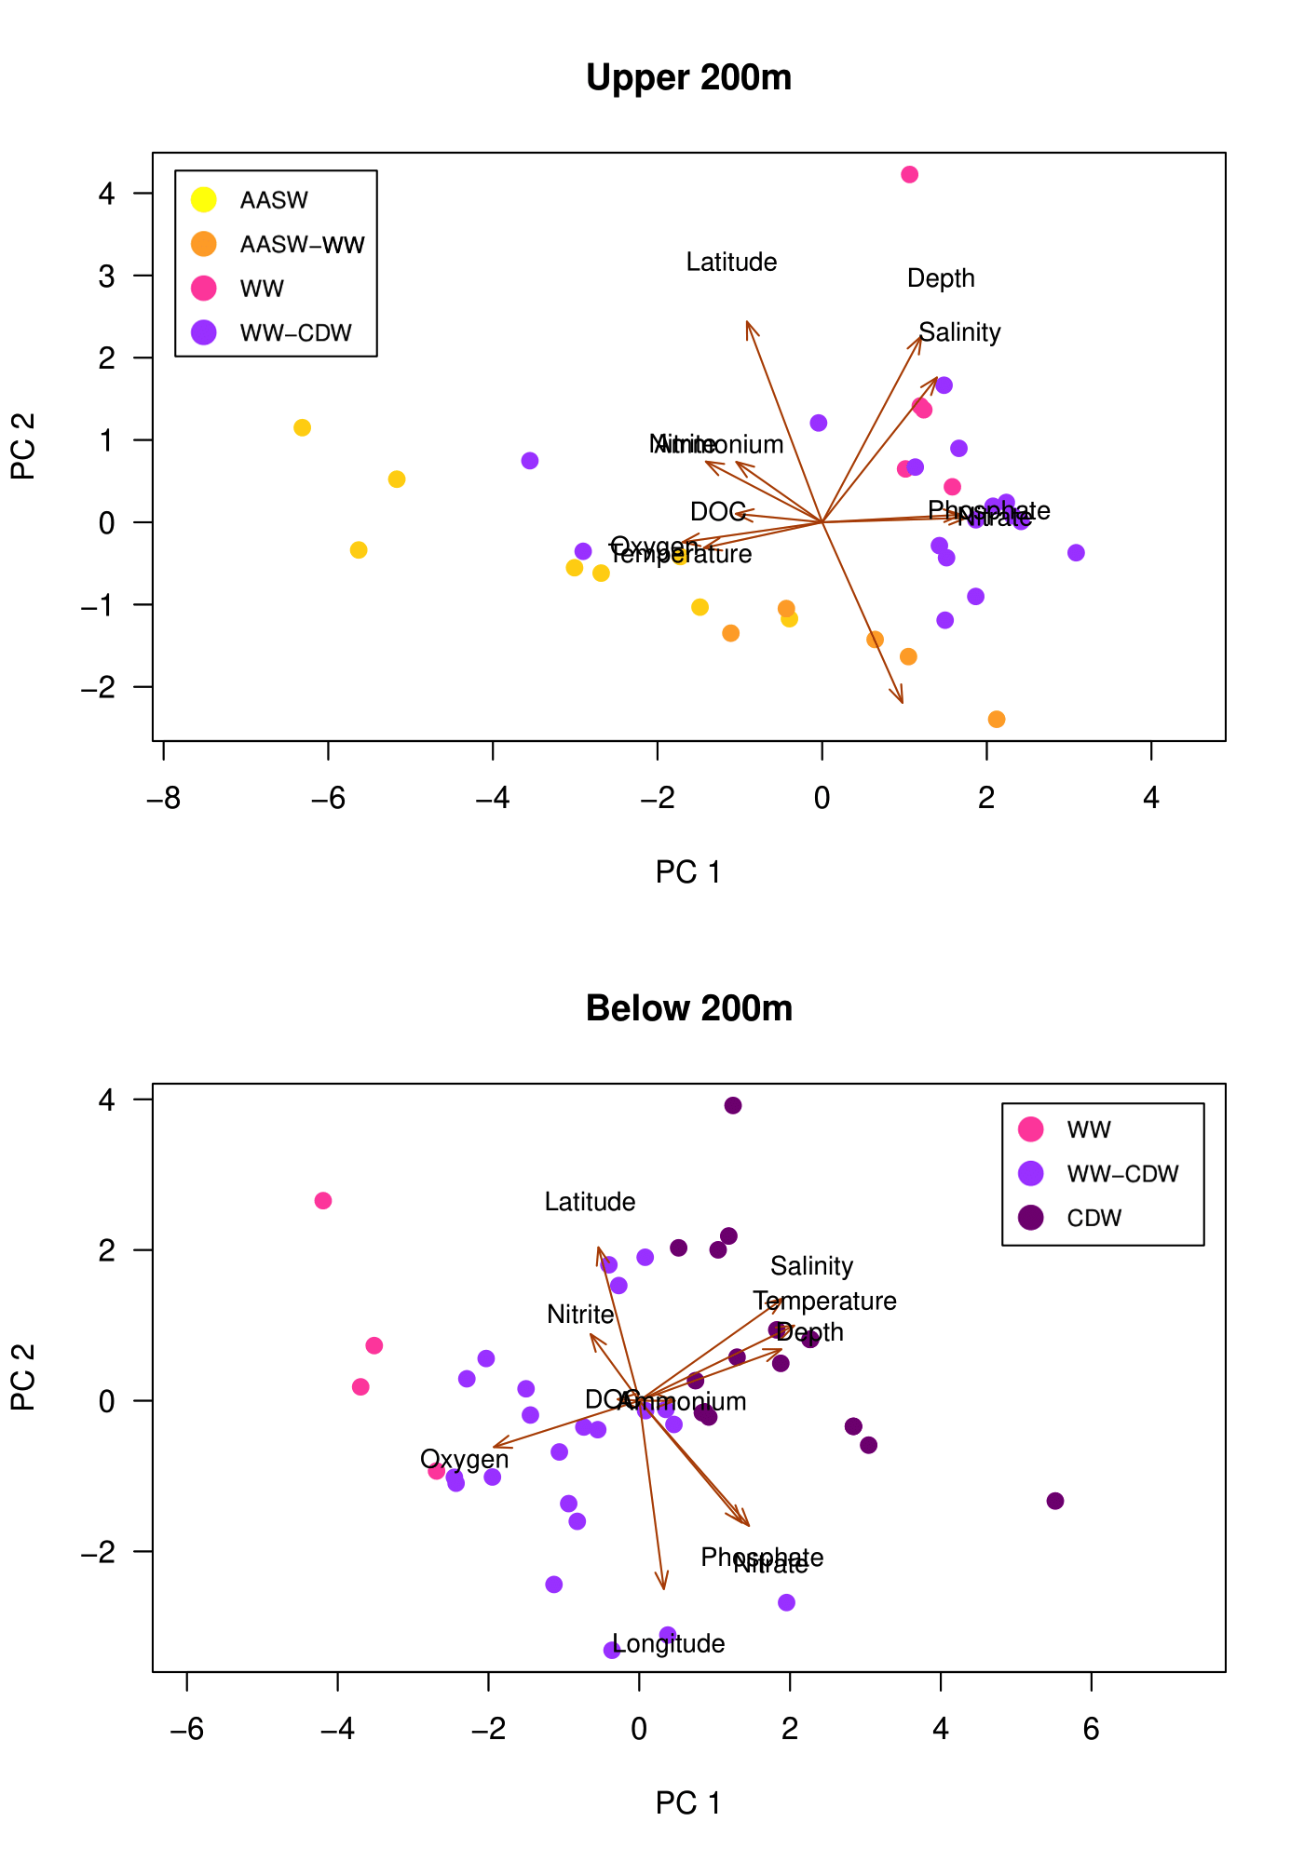

**Figure S7**. PCA of sample metadata by water mass in the ASP. Top PCA is surface-200m and bottom PCA is 200-bottom.



**Figure S8**. Relative abundance by water mass and station at the Family level, including Archaea. Similar to previous relative abundance plot, but includes prevalence of *Nitrosopumilaceae*, a known ammonia-oxidizing archaea.

SUPPLEMENTARY TABLES

**Table S1.** Nutrient ranges for all stations combined.

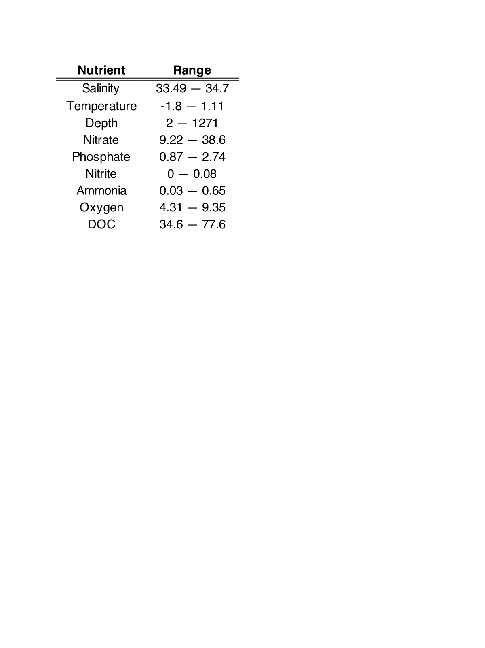

**Table S2.** Inventory ranges per station.

**Table S3.** Indicator species for **free-living** communities based on location, separated into surface-200m (upper 200m) and 200-bottom (below 200m).

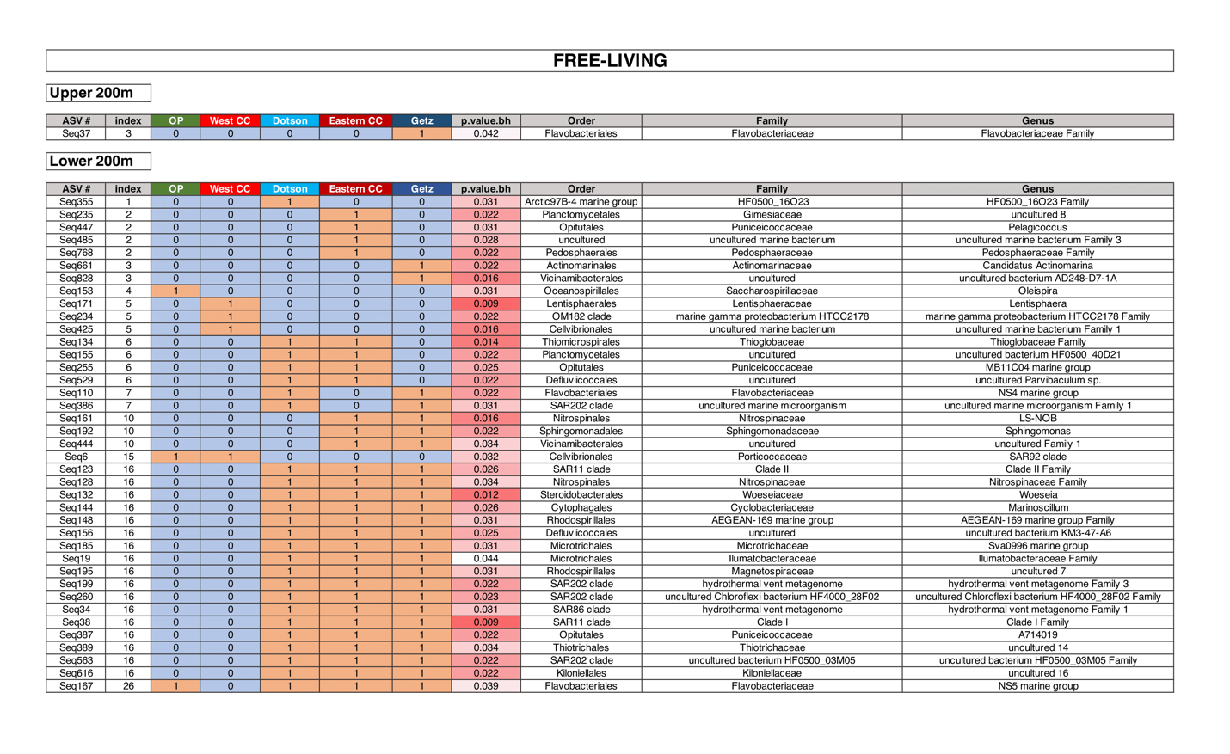

**Table S4.** Indicator species for **particle-associated** communities based on location, separated into surface-200m (upper 200m) and 200-bottom (below 200m). No significant taxa for upper 200m.

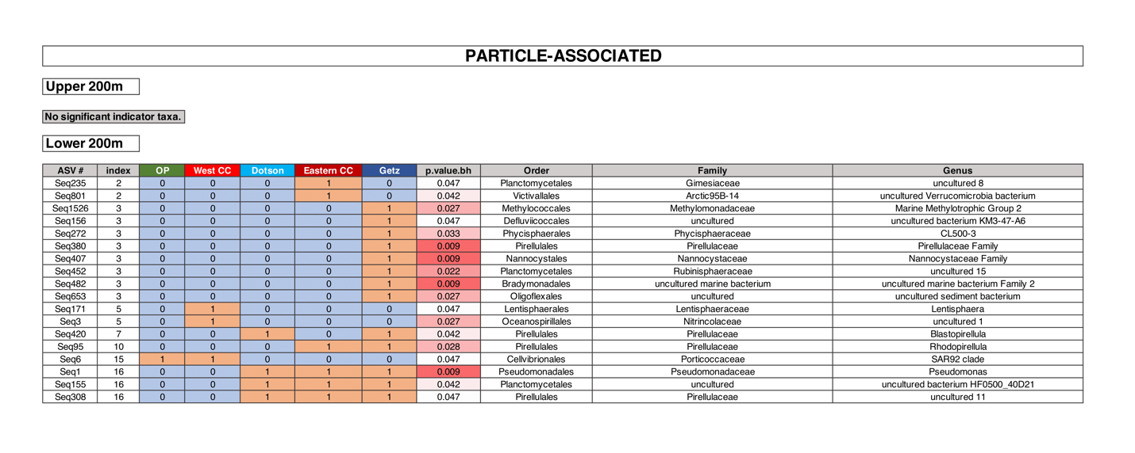

**Table S5.** Indicator species for **free-living** communities based on location for CDW samples ONLY.

